N+ - Network security, Maintenance and Troubleshooting procedures

- Section A: Scenario-Based Concept Application

Q1. Explain the selection process for CPU, RAM, and storage specifications to ensure hardware compatibility and prevent performance bottlenecks for a startup team performing concurrent development and video conferencing tasks.

Answer

- CPU Selection
- Choose a modern multi-core processor such as Intel Core i5/i7 or AMD Ryzen 5/7.
- Select at least 6 cores and 12 threads to support multitasking.
- Ensure the processor supports virtualization if developers use virtual machines.
- Verify that the CPU socket is compatible with the motherboard.
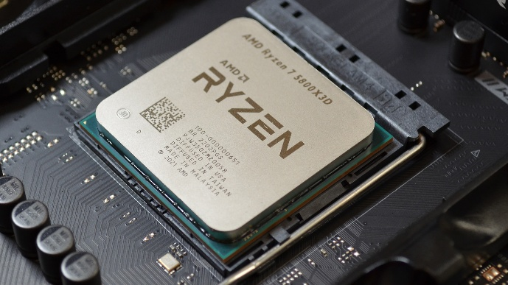

- RAM Selection
- Install a minimum of 16 GB RAM for development work.
- Prefer 32 GB RAM if multiple applications and virtual machines are used.
- Use DDR4 or DDR5 memory according to motherboard compatibility.
- Install RAM in dual-channel configuration for better performance.
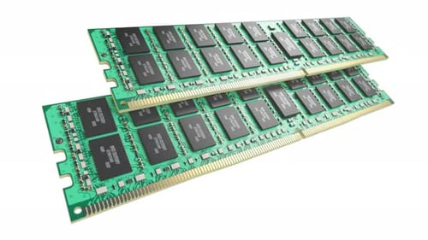

- Storage Selection
- Use an NVMe SSD instead of a traditional HDD.
- Select at least 512 GB SSD; 1 TB is recommended for development projects.
- Store operating system, software, and project files on the SSD to reduce loading time.
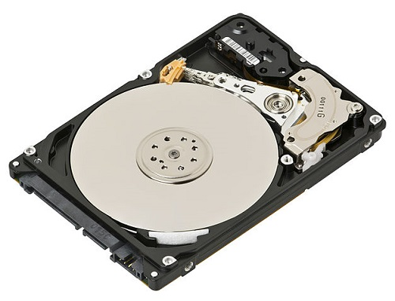

- Hardware Compatibility
- Ensure CPU, RAM, motherboard, and storage interfaces are compatible.
- Check BIOS/UEFI support before installing newer processors.
- Verify power supply capacity for all installed hardware.

- Preventing Performance Bottlenecks
- Use sufficient RAM to avoid excessive paging.
- Use SSD storage to improve application startup and file access.
- Choose a multi-core CPU to handle compiling code and video conferencing simultaneously.
- Keep drivers and BIOS updated for maximum compatibility.

Q2. Explain how system resource allocation and hardware bottlenecks contribute to performance degradation after the deployment of resource-intensive background applications like antivirus software.

Answer

- CPU Utilization
- Antivirus software continuously scans files.
- CPU usage increases significantly during scans.
- High CPU utilization slows other applications.

- Memory Usage
- Antivirus programs consume RAM while running.
- Low available RAM forces Windows to use virtual memory.
- Accessing virtual memory is slower than physical RAM.

- Disk Activity
- Antivirus scans repeatedly read and write files.
- HDD performance becomes slow due to high disk activity.
- SSDs perform better but can still experience heavy workload.

- Background Services
- Multiple startup services consume system resources.
- Excessive background applications reduce overall system responsiveness.

- Hardware Bottlenecks
- Insufficient RAM causes memory bottlenecks.
- Older CPUs take longer to process background tasks.
- Slow HDDs increase application loading time.

- Performance Degradation
- Slow application startup
- System freezing
- Increased boot time
- Delayed file access
- Reduced multitasking capability

- Solution
- Upgrade RAM.
- Replace HDD with SSD.
- Schedule antivirus scans during non-working hours.
- Disable unnecessary startup applications.
- Upgrade CPU if required.

Q3. Explain the systematic troubleshooting process for resolving peripheral hardware failures caused by driver incompatibility or operating system conflicts when a device functions inconsistently across different workstations.

Answer

- Step 1: Identify the Problem
- Observe the symptoms.
- Determine whether the issue occurs on one or multiple systems.

- Step 2: Check Physical Connections
- Verify USB, HDMI, or network cables.
- Test the peripheral on another port.

- Step 3: Test on Another Computer
- Connect the device to another workstation.
- Determine whether the problem is with the device or the computer.

- Step 4: Check Device Manager
- Open Device Manager.
- Look for warning symbols.
- Identify driver-related errors.

- Step 5: Update or Reinstall Drivers
- Download the latest drivers from the manufacturer.
- Remove outdated drivers.
- Restart the system after installation.

- Step 6: Check Operating System Compatibility
- Verify that the operating system supports the device.
- Install compatibility updates if necessary.

- Step 7: Check Windows Updates
- Install pending updates.
- Restart the computer.

- Step 8: Verify BIOS/UEFI Settings
- Ensure required ports are enabled.
- Check USB controller settings.

- Step 9: Test Device Functionality
- Verify proper operation after troubleshooting.

Q4. Explain the role of Uninterruptible Power Supply (UPS) systems and surge protection in preventing file system corruption and ensuring data integrity during unexpected power fluctuations.

Answer

- What is a UPS?
- A UPS is a backup power device that supplies temporary electricity during power failures.

- Functions of UPS
- Provides backup power.
- Allows safe shutdown of computers.
- Prevents sudden system crashes.
- Protects hardware during voltage fluctuations.

- What is Surge Protection?
- A surge protector protects electronic devices from sudden voltage spikes.

- Benefits of Surge Protection
- Prevents motherboard damage.
- Protects hard drives and SSDs.
- Extends hardware lifespan.
- Prevents electrical component failure.

- Preventing File System Corruption
- Sudden shutdown interrupts file writing.
- File systems become corrupted.
- UPS allows files to be saved properly before shutdown.

- Ensuring Data Integrity
- Prevents incomplete file transfers.
- Protects databases from corruption.
- Maintains operating system stability.

- Section B: Practical Application

Task 1: Physically Assemble a Workstation and Document the Component Installation Sequence

Answer

- Wear an anti-static wrist strap.
- Open the computer cabinet.
- Install the CPU into the motherboard socket.
- Apply thermal paste.
- Install the CPU cooler.
- Install RAM modules.
- Mount the motherboard inside the cabinet.
- Install the Power Supply Unit (PSU).
- Install the SSD/HDD.
- Connect SATA data cable.
- Connect SATA power cable.
- Install graphics card (if required).
- Connect front panel connectors.
- Connect power cables (24-pin and CPU 8-pin).
- Check all cable connections.
- Close the cabinet.
- Connect monitor, keyboard, and mouse.
- Power on the system.
- Verify successful POST.

Task 2: Troubleshoot and Resolve a RAM Mismatch Error within BIOS/UEFI Settings

Answer

- Shut down the computer.
- Remove the power cable.
- Open the cabinet.
- Remove the RAM modules.
- Check RAM type (DDR4/DDR5).
- Verify RAM speed compatibility.
- Install RAM in the correct motherboard slots.
- Boot into BIOS/UEFI.
- Verify installed RAM capacity.
- Enable XMP/DOCP profile if supported.
- Save BIOS settings.
- Restart the system.
- Confirm that all RAM is detected correctly.

Task 3: Build a LAN Topology in Cisco Packet Tracer for 5 Systems and 1 Printer Using a Class C Subnet

Answer
- Devices
- 1 Switch
- 5 PCs
- 1 Printer
- Network
- Network Address: 192.168.1.0/24

Device | IP Address | Subnet Mask
PC1 | 192.168.1.10 | 255.255.255.0
PC2 | 192.168.1.11 | 255.255.255.0
PC3 | 192.168.1.12 | 255.255.255.0
PC4 | 192.168.1.13 | 255.255.255.0
PC5 | 192.168.1.14 | 255.255.255.0
Printer | 192.168.1.20 | 255.255.255.0

- Steps
- Add one switch.
- Connect all devices using Copper Straight-Through cables.
- Assign IP addresses.
- Save the configuration.
- Test connectivity using the ping command.
- Verify all devices respond successfully.

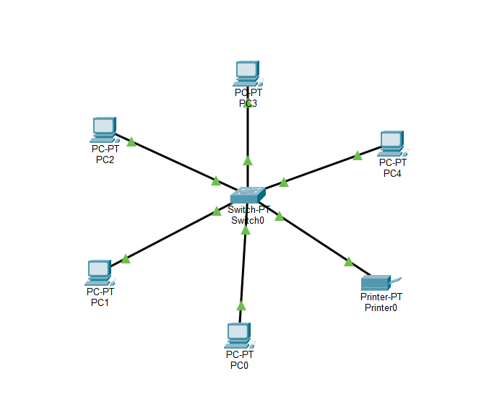

Task 4: Perform a Clean OS Installation with Manual Disk Partitioning and Startup Optimization

Answer

- Installation Steps
- Create a bootable USB.
- Boot from USB.
- Select language and keyboard layout.
- Click Install Now.
- Select Custom Installation.
- Delete old partitions (if required).
- Create new partitions:
  - EFI System Partition
  - System Reserved
  - C: Drive (OS)
  - D: Drive (Data)
- Select the C: partition.
- Install Windows.
- Complete setup.
- Install motherboard drivers.
- Install network drivers.
- Install graphics drivers.
- Run Windows Update.

- Startup Optimization
- Disable unnecessary startup applications.
- Enable Fast Startup.
- Update drivers.
- Remove unwanted software.
- Verify antivirus is installed.
- Restart the computer.

- Section C: Practical Application

- Scenario:
At Nexus Innovations, three rendering workstations pass morning POST checks but restart randomly during heavy afternoon workloads. The units are stored in poorly ventilated desk cabinets.

Q1. Identify the three hardware components most likely to cause random reboots under load.

Answer

The three hardware components most likely responsible for random reboots are:

1. CPU (Processor)
- During rendering, the CPU operates at high usage.
- If the CPU temperature exceeds the safe limit, the system automatically shuts down or restarts to prevent damage.

2. Power Supply Unit (PSU)
- A low-quality or insufficient PSU may fail to supply stable power during heavy workloads.
- Voltage drops can cause unexpected system restarts.

3. CPU Cooling System (Heat Sink/Fan)
- Dust buildup or poor airflow reduces cooling efficiency.
- The CPU overheats because the cooler cannot remove heat effectively.
- This leads to thermal shutdowns or random restarts.

Q2. Explain why the systems pass POST in the morning but fail in the afternoon.

Answer

- Morning
- The workstations are cool after being powered off overnight.
- Ambient room temperature is lower.
- The systems easily complete the Power-On Self-Test (POST).

- Afternoon
- Continuous rendering generates a large amount of heat.
- Poor ventilation inside the desk cabinets traps hot air.
- Internal temperatures continue to rise.
- The CPU or other components exceed their safe operating temperature.
- The motherboard activates thermal protection and restarts the computer.

Q3. How would you use a stress-test tool to confirm a thermal or power issue?
Answer

- Step 1
- Boot the workstation normally.

- Step 2
- Install a hardware monitoring tool to observe CPU temperature, GPU temperature, voltages, and fan speed.

- Step 3
- Run a stress-test application to place the CPU and GPU under full load.

- Step 4
- Monitor:
- CPU temperature
- GPU temperature
- PSU voltage stability
- Fan speeds

- Step 5
- Observe the system during the test.

- Results
- If temperatures exceed safe limits and the computer restarts, the issue is thermal.
- If temperatures remain normal but the system still restarts, the PSU may be unable to provide stable power.

Q4. Propose three specific steps to remediate the frequent system restarts.
Answer

- Step 1: Improve Airflow
- Remove the workstations from enclosed desk cabinets.
- Place them in a well-ventilated area.
- Ensure proper airflow around the cabinets.

- Step 2: Clean and Maintain Cooling Components
- Remove dust from CPU heatsinks, fans, and air vents.
- Replace old thermal paste if necessary.
- Verify that all cooling fans are functioning correctly.

- Step 3: Check the Power Supply
- Test the PSU output.
- Replace the PSU if it cannot provide sufficient or stable power.
- Use a PSU with an appropriate wattage rating for rendering workloads.

Q5. Provide a brief technical justification for why a PSU upgrade might (or might not) be necessary.
Answer

- A PSU upgrade may be necessary if:
- The current PSU has insufficient wattage for the CPU, GPU, and other components.
- The PSU produces unstable voltage under heavy load.
- The PSU is old or showing signs of failure.
- A PSU upgrade may not be necessary if:
- The existing PSU provides enough wattage.
- Voltage output remains stable during stress testing.
- The actual cause of the problem is overheating due to poor ventilation or cooling issues.

- Technical Justification:
A PSU should only be upgraded after testing confirms that it cannot supply stable and sufficient power. If temperatures are the primary cause of the restarts, improving cooling and airflow is the correct solution rather than replacing the PSU.

